**STUDENT INFORMATION SYSTEM**

*A Project work report submitted to Pokhara University in partial fulfillment of the requirements for the degree of*

**BACHELOR OF COMPUTER APPLICATION**

PRJ 251.2 PROJECT II

SUBMITTED BY

SANTOSH PANDIT 18530037

SAROJ SHRESTHA 18530038

YOGESH CHAUDHARY 18530044

at the

School of Environmental Science and Management (SchEMS)

Pokhara University

December 2019

# DECLARATION

We hereby declare that the project work report entitled “Student Information System” submitted for the partial fulfillment of Bachelor of Computer Application is our original work and the Project Work Report has not formed the basis for the award of any degree, diploma, or other similar titles.

Name of Student: Santosh Pandit

Signature:

Name of Student: Saroj Shrestha

Signature:

Name of Student: Yogesh Chaudhary

Signature :

# BONAFIDE CERTIFICATE

# Abstract

Student Information System manages student details and record their examination performance. Here, we can view their details, and generate the reports. Student Information System has four modules. Initially, admin will enter all the student’s detail during admitted date and leaving date module. Later he/she is going to upload the details of student, called student data module which has the functionalities like searching, inserting, updating and deleting the student data. At the end of the session report will be generated, called report module. The project is developed in .net framework and MySQL which is open source.

**Keywords:** Student Information System, Student data module, report module, MySQL

# 

# ACKNOWLEDGEMENT

This project is prepared in the partial fulfillment of the requirement for the degree of Bachelor of Computer Application (BCA). The satisfaction and success of completion of this task would be incomplete without heartfelt thanks to people whose constant guidance, support and encouragement made this work successful.

By the blessing of god, we have prepared this project on student record management system on the course of Database management system and Visual programming for BCA, Pokhara University.

We are very grateful to our honorable sir Er.Binod Bhandari for assisting us throughout the working time. He helped us by sharing his invaluable knowledge and experience to us. We also like to thank our mam program co-coordinator Er. Rama Bastola for supervising us during the project period. She helped us gathering the information and encouraging us to complete the project.

We also like to thanks our friends for their participation and providing time and attendance during the working period.

Last but not the least we want to thank every direct and indirect hands that were involved in completion of this project. Finally, we take this opportunity to mention our sincere thanks to all friends who helped us directly or indirectly for the completion of our project.

This project has been a wonderful experience where we have learnt and experienced many beneficial things.

# TABLE OF CONTENTS

**DECLARATION 2**

**BONAFIDE CERTIFICATE 3**

**ABSTRACT 4**

**ACKNOWLEDGEMENT 5**

**TABLE OF CONTENTS 6**

**FIGURES 8**

**CHAPTER 1 INTRODUCTION 9**

1.1 INTRODUCTION 9

**1.2 PROBLEM STATEMENT 9**

**1.3 OBJECTIVES 10**

**1.4 APPLICATIONS 10**

**1.5 PROJECT FEATURES 10**

**1.7 SYSTEM REQUIREMENT 11**

**CHAPTER 2: LITERATURE REVIEW 12**

2.1 STUDENT INFORMATION SYSTEM 12

**CHAPTER 3: DESIGN & METHODOLOGY 14**

3.1 ENTITY RELATIONSHIP DIAGRAM 14

3.2 SYSTEM FLOW DIAGRAM 15

3.3 DATA FLOW DIAGRAM 16

**CHAPTER 4: IMPLEMENTATION AND RESULT 17**

4.1 IMPLEMENTATION DETAIL 17

4.2 RESULT ANALYSIS 21

**CHAPTER 5: CONCLUSION AND FUTURE ENHANCEMENT 25**

5.1 CONCLUSION 25

5.2 FUTURE ENHANCEMENT 25

**REFERENCE 26**

**APPENDICES 27**

1. SOURCE CODE 27

# FIGURES

Figure3.1. 1 ER-Diagram for Student Information System 14

Figure3.2. 1 System flow diagram of Student Information System 15

Figure3.3. 1 Data flow diagram of Student Information System……………………………..17

Figure4.1. 1 Login code……………………………………………………………………...18

Figure4.1. 2 Showing the table data in page 19

Figure4.1. 3 Inserting new student 20

Figure4.1. 4 Calculation of SGPA of a student 21

Figure4.2. 1 Login Screen……………………………………………………………………22

Figure4.2. 2 Adding new student 23

Figure4.2. 3 Adding student’s academic information 23

Figure4.2. 4 Showing the courses 24

Figure4.2. 5 Showing the grading system of PU 24

Figure4.2. 6 Showing the examination records of students 25

Figure4.2. 7 Calculating SGPA of a student 25

# CHAPTER 1 INTRODUCTION

## 1.1 INTRODUCTION

As colleges got expanded the number of students also gets increased and also the student related contents increases. Student Information System is application software which is deliberated to begin with exchange of information in a secure manner to affiliate with students, faculties, semester result, parents and the college/school administration. The suggested system contains whole data regarding information of the student in regular intervals. The admin will enter the student data containing the information (like mobile number, class, date-of-birth, sex, email-id, parent name, registration number, roll number, id, semester and result). These statistics will be stored in the database. This application can be effortlessly used in any educational institutions. In private and government educational institutions also, it can be implemented.

Also the existing system used paid software for database which increases the cost but we used the free software MYSQL for the database and VISUAL STUDIO for Graphical User Interface (GUI).Hence we developed this Student Information System, which fulfills the requirement of institution affiliated to Pokhara University and also this system keep record of student as well as their academic performance using this single system rather than two different system.

### **1.2 PROBLEM STATEMENT**

With increase in numbers of students in colleges/schools, keeping record in written format takes more time and effort to access the information of the required student. Also, it is time consuming with very weak security, student details can be easily leaked and may be misused. For the security reason and time saving it is very essential to make the system automatically. Moreover, the existing system developed are mostly focused on keeping records of personal info’s and academic information of a student.

### **OBJECTIVES**

The objectives of the project are mentioned below:

* To record the students details for the present as well as future purpose.
* To provide fast accurate and consistent response.
* To access the student’s records and get the desired information.
* To automate the existing system of manually storing student records, students details and academic (exam) information.

### **1.4 APPLICATIONS**

This project will be implemented in all the educational institute to record all student information from admitted date to pass out date. We can easily implement our system in schools, colleges and other educational institutes. As, the system requirement are simple and the software's used are either open source.

### **1.5 PROJECT FEATURES**

* Store student information: This system simply store the student information such as name, id, address, parent name, contact information and many other informations of the colleges affiliated to Pokhara University.
* Store course information: Another features of this project is it keeps record of the courses that students studied in different semesters.
* Academic information: Also the project next feature is to store the academic performance as result of the students.

### **1.7 SYSTEM REQUIREMENT**

To design any system, program, application or software, there is use of hardware and software that helps to run effective and efficiently most of the computer programs. These requirements are known as system requirements which is used as software guideline to run the software smoothly normally system requirement are categorize into two parts software and hardware requirement. This software is developed using **VB.net** programming language on visual studio which uses the latest dot net framework. In the context of the student record management system uses the **MySQL** as the database management system.

### 

# CHAPTER 2: LITERATURE REVIEw

## 2.1 STUDENT INFORMATION SYSTEM

On observing the students information system currently used in different educational institute, we came to point out that the system to record examination and student information, was two different system. One was for student record and another for examination. Another point is, Pokhara University follows its own type of rules, regulation and its system is different than others Universities.

Also the existing system used paid software for database which increased the cost but we used the free software MYSQL for the database and VISUAL STUDIO for Graphical User Interface (GUI).Hence we developed this Student Information System, which fulfills the requirement of institution affiliated to Pokhara University and also this system keep record of student as well as their academic performance using this single system rather than two different system.

The system has come up with functionalities for educational institutions to track the student profile record, either they are studying or they have left the institution with academic performance in each semester. All the information are stored in the database so that it is easy to manage and track student details. To overcome difficulties we come up with this new approach student information system with additional features. This new approach will provide fast processing, efficient student tracking, and produces desired result. This approach will allow students to save their personal details. It is more secure, reliable and easy to use.[2]

The faculties can also do the necessary functions like registering new students, deleting the information about a particular student, modifying the information regarding the student etc. The main intention of this process is to reduce the risk of manual efforts. It also reduces the time consumption. Also we want to give importance to reduce the paper wastage that daily happens. The model utilizes computer aided system. The model plays main role in an institution or in the college management. Initially, the system has developed with four layers based on the hierarchy such as Web display layer where application is deployed and displayed for end users. Business logic layer responsible for handling the functionality of the product. Data access layer is responsible for viewing the data. Database layer responsible for storing the student data. In Database layer ER diagram has been designed to provide data normalization. The process provides complete information about student and educational institution.

All data stored and retrieved through the application is secure. So to achieve this we have developed a Windows based secured interface application which supports all type of request which are coming from the students also which gathers and corrects all student information. The papers will explains how it is playing an important role in the education domain. This system is provides seamless access through the windows based application to access and manage different department or all over the organization. This system is developed for all institution college it will provide end users to maintain their data with minimum effort. Initially faculties/students get registered with the system once they finish registration process they can access the system as well as they are able to do the changes in the data. As per the requirement users has been granted with certain level permission to manage and track the student information.[3]

# CHAPTER 3: Design & METHODOLOGY

## 3.1 ENTITY RELATIONSHIP DIAGRAM

An entity relationship diagram shows the relationships of entity sets stored in a database. It is high level conceptual data model diagram. Entity relation model is based on the notion of real-world entities and the relationship between them. It helps us to analyze data requirements systematically to produce a well-designed database. So, it is considered a best practice to complete ER modeling before implementing the database.

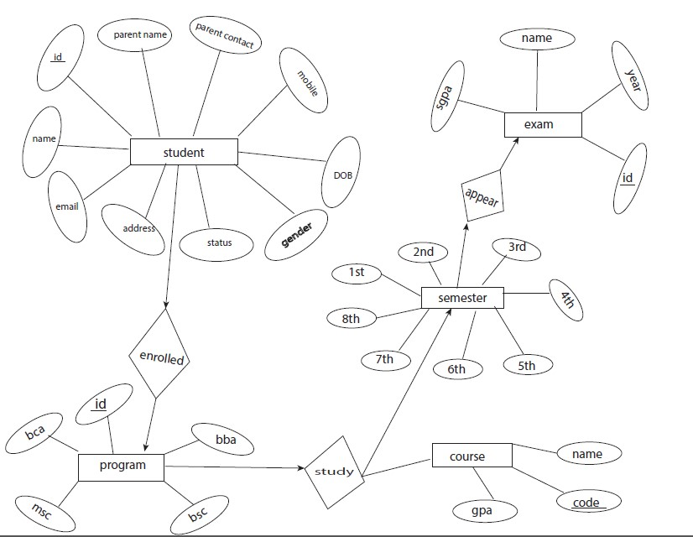

Figure3.1. 1 ER-Diagram for Student Information System

## 3.2 SYSTEM FLOW DIAGRAM

Also known as the name data flow diagram which are used to graphically represent the flow of information or data. It uses defined symbols like rectangles, circles and arrows, plus short text labels, to show data inputs, outputs, storage points and the routes between each destination.

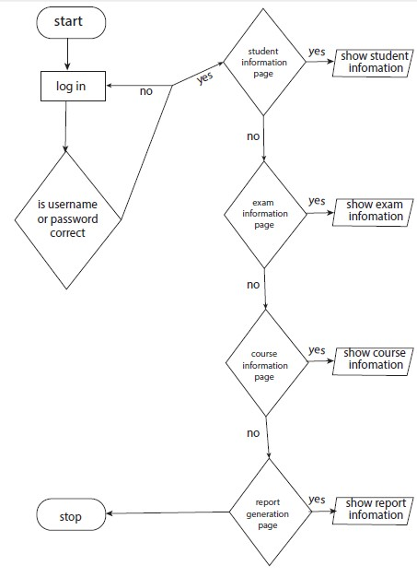

Figure3.2. 1 System flow diagram of Student Information System

## 3.3 DATA FLOW DIAGRAM

Also known as the name data flow diagram which are used to graphically represent the flow of information or data. It uses defined symbols like rectangles, circles and arrows, plus short text labels, to show data inputs, outputs, storage points and the routes between each destination.

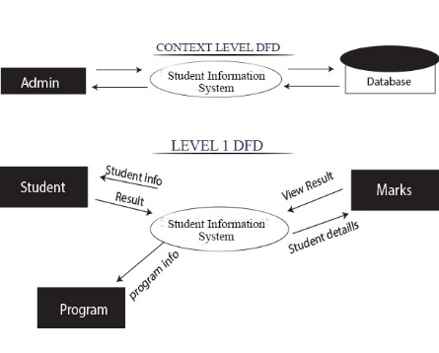

Figure3.3. 1 Data flow diagram of Student Information System

# CHAPTER 4: IMPLEMENTATION AND RESULT

## 4.1 IMPLEMENTATION DETAIL

The major parts of the system implementation are presented below:

Imports MySql.Data.MySqlClient

Public Class Form1

Dim str As String = "server=localhost; uid=root; pwd=; database=student_information;" 'to connect with the database

Dim con As New MySqlConnection(str)

Private Sub Button1_Click(sender As Object, e As EventArgs) Handles Button1.Click

Dim cmd As New MySqlCommand("SELECT `Username`, `Password`

FROM `user_login`

WHERE`Username`=@usernameAnd`Password` =@password", con)

cmd.Parameters.Add("@username", MySqlDbType.VarChar).Value = TextBox1.Text

cmd.Parameters.Add("@password", MySqlDbType.VarChar).Value = TextBox2.Text

Dim adapter As New MySqlDataAdapter(cmd)

Dim table As New DataTable()

adapter.Fill(table)

If table.Rows.Count = 0 Then

MessageBox.Show("Invalid username or password", "Student Information System")

Else

MessageBox.Show("login Successful ", "Student Information System")

Me.Hide()

Form2.Show()

End If

End Sub

Figure4.1. 1 Login code

Figure4.1. 2 Showing the table data in page

Imports MySql.Data.MySqlClient

Public Class Form2

'to establish a connection between vb.net and mysql

Dim str As String = "server=localhost; uid=root; pwd=; database=student_information;"

Dim con As New MySqlConnection(str)

Dim ds As New DataTable

'to load the databasein the datagridview of vb.net from mysql

Shadows Sub Load()

ds.Clear()

Dim query As String = "SELECT `Student_ID`,`S_Name`, `Gender`, `Cell_number`, `Address`, `DOB`, `Email_ID`, `ParentsName`, `P_contact_no`, `Program`, `Status`

FROM `student_info`

WHERE 1"

Dim adpt As New MySqlDataAdapter(query, con)

adpt.Fill(ds)

DataGridView1.DataSource = ds

con.Close()

TextBox7.Clear()

TextBox1.Clear()

ComboBox1.ResetText()

TextBox4.Clear()

TextBox3.Clear()

DateTimePicker1.ResetText()

TextBox6.Clear()

TextBox5.Clear()

TextBox8.Clear()

ComboBox2.ResetText()

ComboBox3.ResetText()

Label12.Hide()

TextBox7.Hide()

End Sub

The fig4.1.2 shows the data of the students from the database to the second form/page of the system

Figure4.1. 3 Inserting new student

Private Sub Button6_Click(sender As Object, e As EventArgs) Handles Button6.Click

Dim cmd As MySqlCommand

Try

con.Open()

cmd = con.CreateCommand

cmd.CommandText = ("Insert into student_info(`Student_ID`, `S_Name`, `Gender`, `Cell_number`, `Address`, `DOB`, `Email_ID`,`ParentsName`,`P_contact_no`,`Program`,`Status`) values(@id,@name,@gen,@cell,@addr,@dob,@email,@pname,@pcell,@prog,@status)")

cmd.Parameters.AddWithValue("@id", TextBox7.Text)

cmd.Parameters.AddWithValue("@name", TextBox1.Text)

cmd.Parameters.AddWithValue("@gen", ComboBox1.Text)

cmd.Parameters.AddWithValue("@cell", TextBox4.Text)

cmd.Parameters.AddWithValue("@addr", TextBox3.Text)

cmd.Parameters.AddWithValue("@dob", DateTimePicker1.Text)

cmd.Parameters.AddWithValue("@email", TextBox6.Text)

cmd.Parameters.AddWithValue("@pname", TextBox5.Text)

cmd.Parameters.AddWithValue("@pcell", TextBox8.Text)

cmd.Parameters.AddWithValue("@prog", ComboBox2.Text)

cmd.Parameters.AddWithValue("@status", ComboBox3.Text)

cmd.ExecuteNonQuery()

ds.Clear()

Load()

MessageBox.Show("New Student has been added", "Student Informtion Sytem")

Catch ex As Exception

MessageBox.Show("!! Empty fields. Please enter valid values", "Student Information System")

End Try

con.Close()

End Sub

Figure4.1. 4 Calculation of SGPA of a student

Private Sub Button7_Click(sender As Object, e As EventArgs) Handles Button7.Click

If TextBox2.Text <> String.Empty Then

ListBox1.Items.Add(TextBox2.Text)

TextBox2.Clear()

End If

End Sub

Private Sub Button3_Click(sender As Object, e As EventArgs) Handles Button3.Click

Dim total1 As Double

Dim gc1 As Integer

Dim g1 As Integer

Dim avg As Double

total1 = 0

gc1 = 0

Do While gc1 < ListBox1.Items.Count

g1 = ListBox1.Items(gc1)

total1 += g1

gc1 += 1

Loop

If gc1 <> 0 Then

avg = total1 / ListBox1.Items.Count

End If

Label14.Text = String.Format("{0:F}", avg)

End Sub

Private Sub Button4_Click(sender As Object, e As EventArgs) Handles Button4.Click

ListBox1.Items.Clear()

Label14.Text = String.Empty

End Sub

## 4.2 RESULT ANALYSIS

The system is developed to keep records of student along with their academic information in educational fields. This system is tested with data enter to it and it produces the output as per the requirement of the users. The pictures of the software are shown below: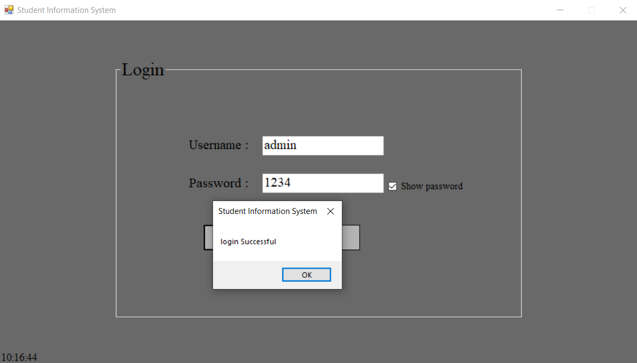

Figure4.2. 1 Login Screen

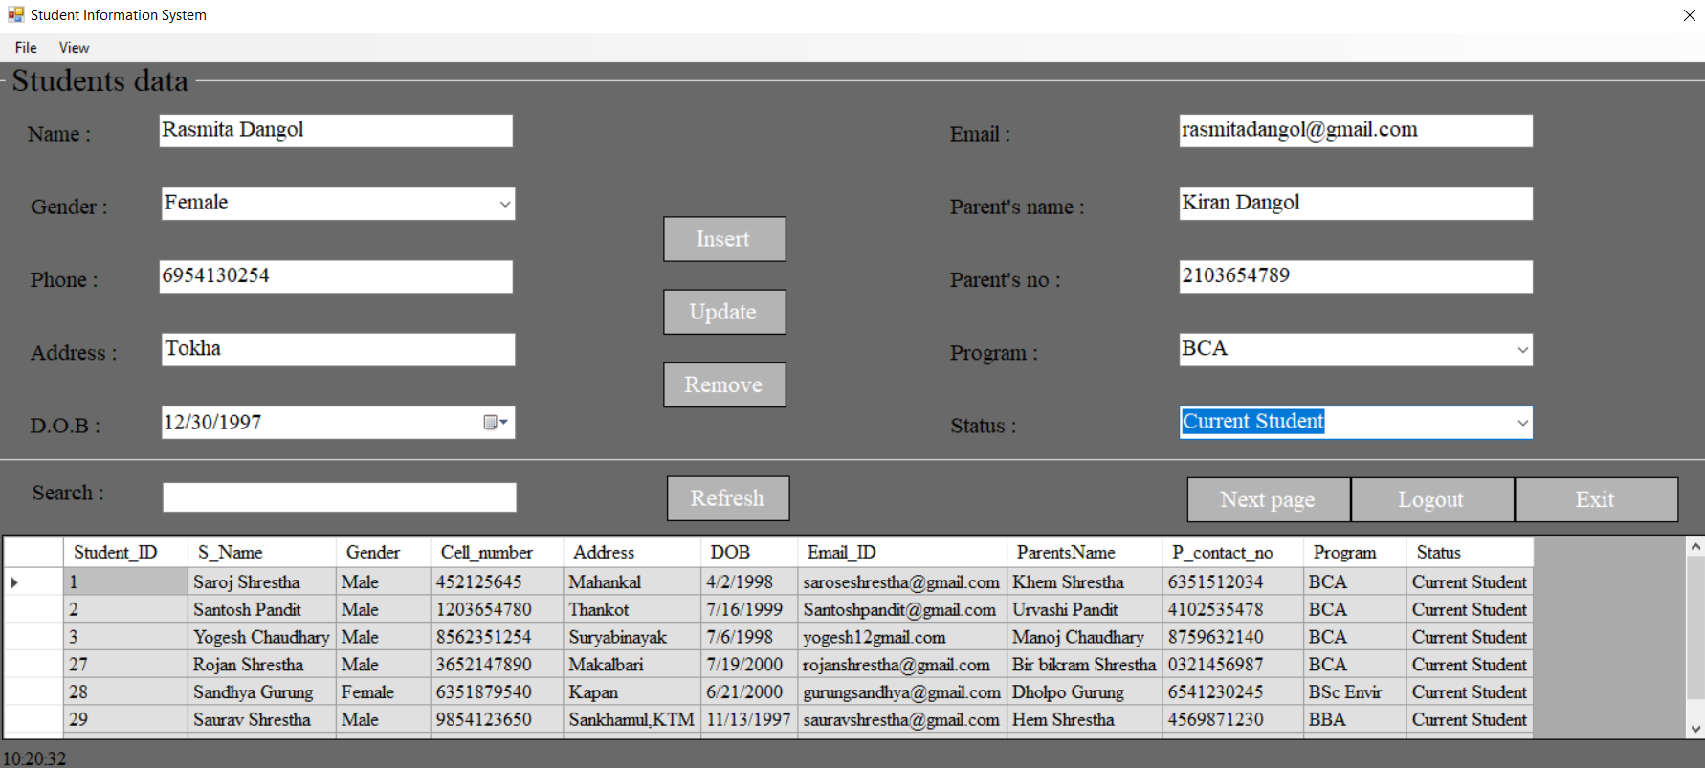

Figure4.2. 2 Adding new student

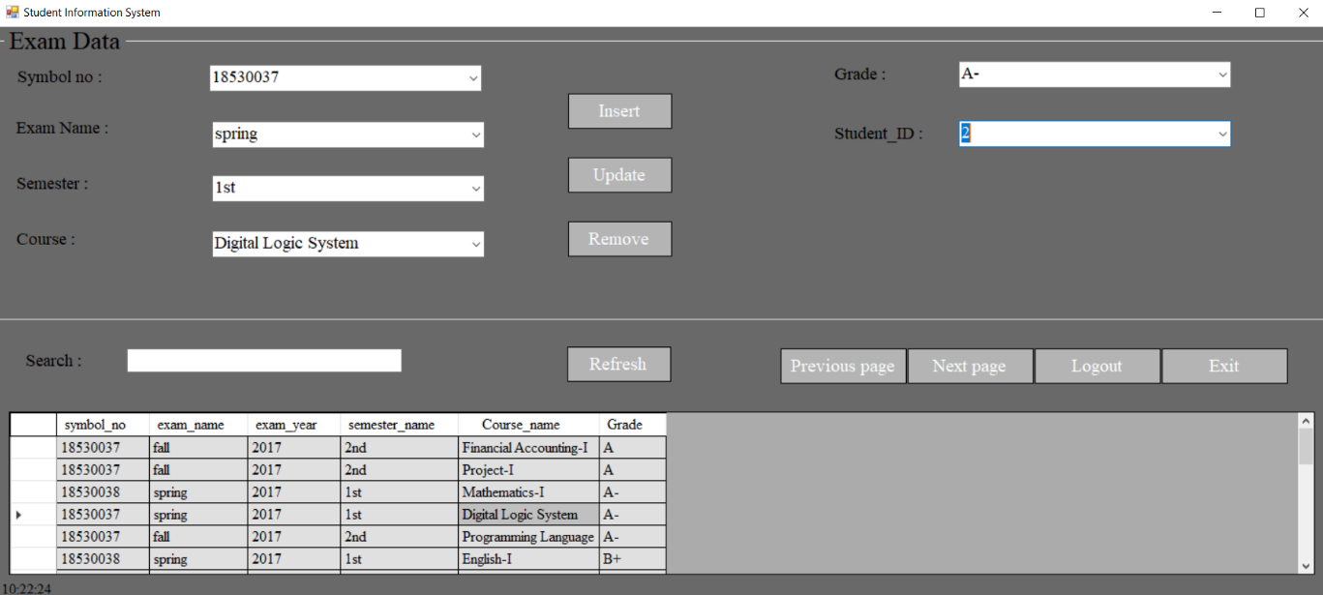

Figure4.2. 3 Adding student’s academic information

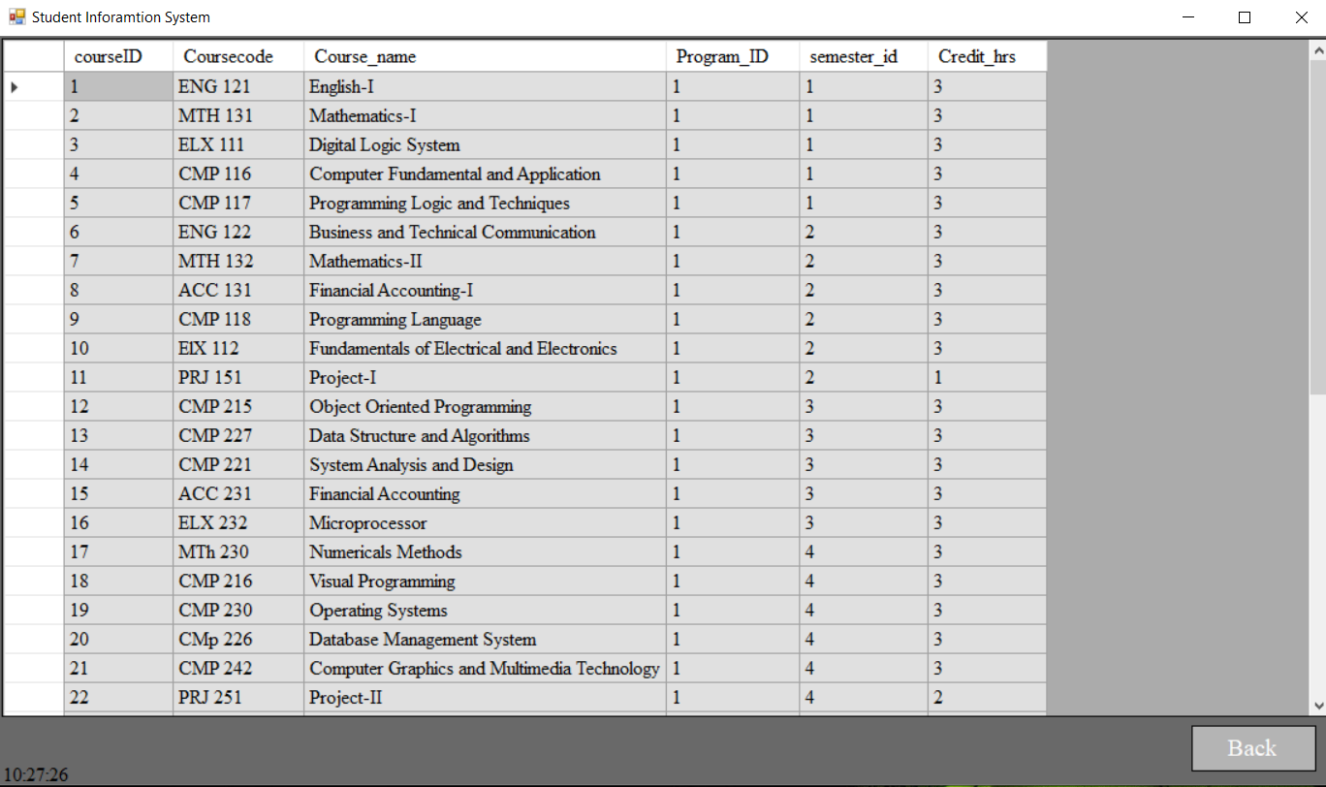

Figure4.2. 4 Showing the courses

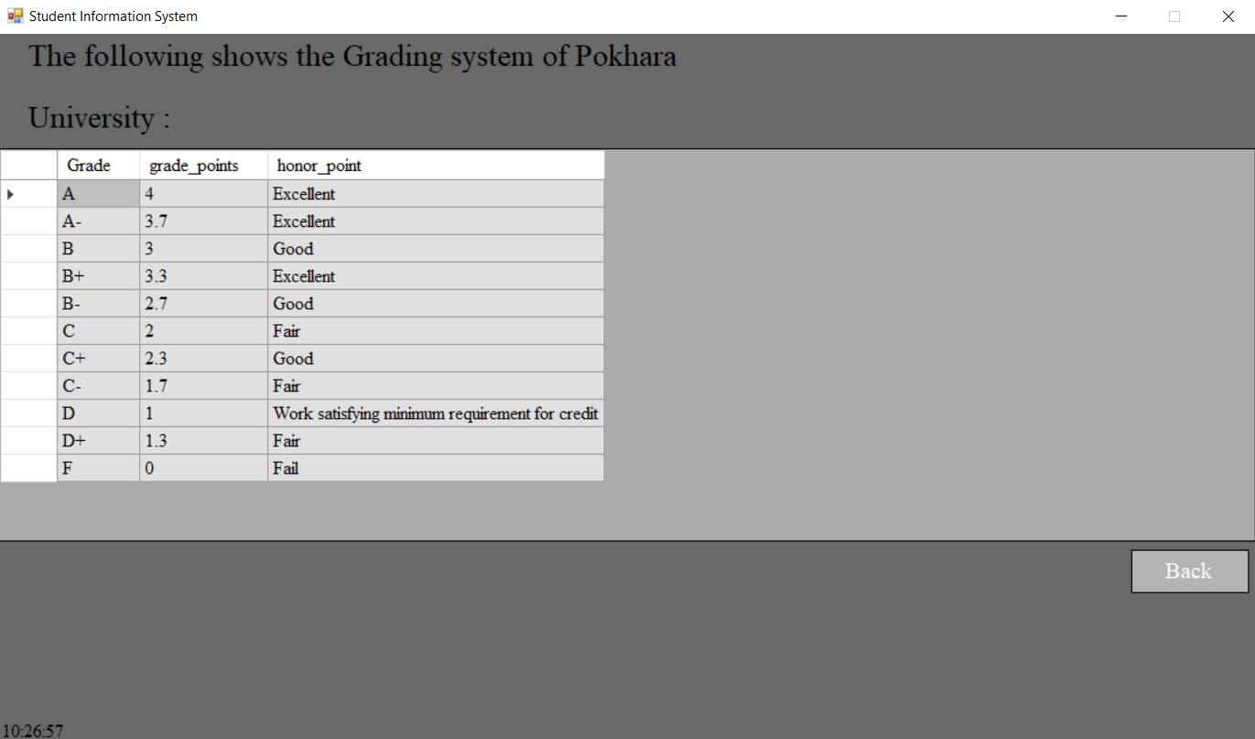

Figure4.2. 5 Showing the grading system of PU

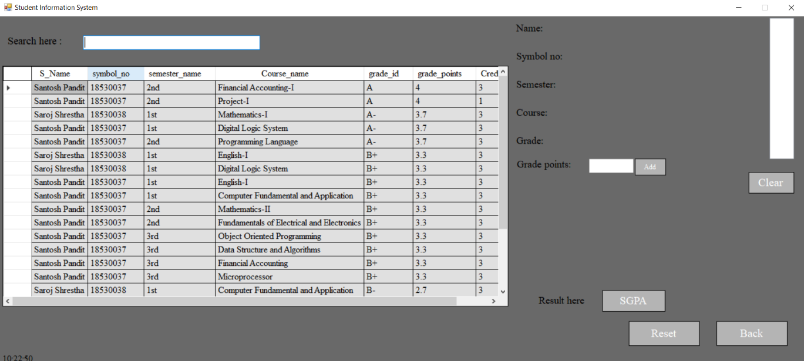

Figure4.2. 6 Showing the examination records of students

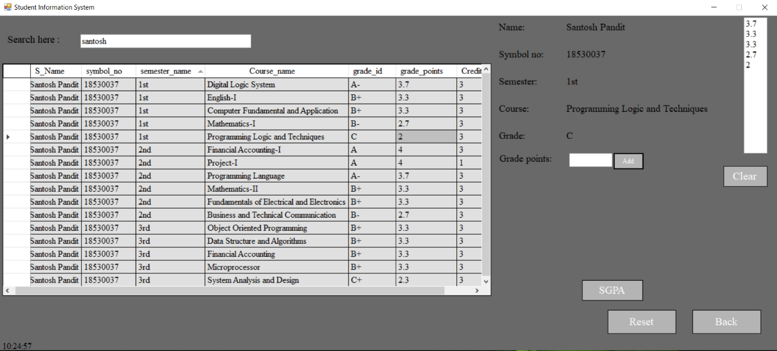

Figure4.2. 7 Calculating SGPA of a student

# CHAPTER 5: CONCLUSION AND FUTURE ENHANCEMENT

## 5.1 CONCLUSION

This system was developed for the educational institute by using open source software VISUAL STUDIO and MYSQL. This system assists in automating the existing manual system. This system reduce paperless work and the man power required. It provides accurate information always. All years together gathered information can be saved and accessed at any time. The data that is stored in repository can be used to take intelligent decisions by the management.

As for the conclusion, the objectives for this project were achieved and functioned well as the desired target. This system will help the student management system database works systematically and will make ease the user in order to manage all the student data in the system. This system will give a better performance in arranging the examination records and student information without having to do it manually. As the future recommendation, the project is recommended to be built with the fully functional software that fulfills all the criteria needed and also with more complicated algorithm to the system.

## 5.2 FUTURE ENHANCEMENT

The project has a very wide scope in future. Some of the possible future enhancements are given below.

* Accessed through web application
* Implemented for others programs such as BBA, BSC, and MSC.

# Reference

[1]"Student Profile Management System", *indiamart.com*, 2019. [Online]. Available: https://www.indiamart.com/proddetail/student-profile-management-system-14279710997.html. [Accessed: 14- Aug- 2019].

[2]"Student information system", *En.wikipedia.org*, 2019. [Online]. Available: https://en.wikipedia.org/wiki/Student_information_system. [Accessed: 14- Aug- 2019].

[3]<https://www.academia.edu/35228990/student_management_system_project_report>[Accessed 2-Oct-2019]

[4]<http://www.geeksforgeeks.org/introduction-to-net-framework> [Accessed 2-Oct-2019]

# Appendices

## SOURCE CODE

‘ *********************Login page**********************

Imports MySql.Data.MySqlClient

Public Class Form1

Dim str As String = "server=localhost; uid=root; pwd=; database=student_information;"

Dim con As New MySqlConnection(str)

Private Sub Button1_Click(sender As Object, e As EventArgs) Handles Button1.Click

Dim cmd As New MySqlCommand("SELECT `Username`, `Password`

FROM `user_login`

WHERE `Username` = @username And `Password` =@password", con)

cmd.Parameters.Add("@username", MySqlDbType.VarChar).Value = TextBox1.Text

cmd.Parameters.Add("@password", MySqlDbType.VarChar).Value = TextBox2.Text

Dim adapter As New MySqlDataAdapter(cmd)

Dim table As New DataTable()

adapter.Fill(table)

If table.Rows.Count = 0 Then

MessageBox.Show("Invalid username or password", "Student Information System")

Else

MessageBox.Show("login Successful ", "Student Information System")

Me.Hide()

Form2.Show()

End If

End Sub

Private Sub Button2_Click(sender As Object, e As EventArgs) Handles Button2.Click

Close()

End Sub

Private Sub Form1_Load(sender As Object, e As EventArgs) Handles MyBase.Load

Timer1.Enabled = True

End Sub

Private Sub Timer1_Tick(sender As Object, e As EventArgs) Handles Timer1.Tick

Label3.Text = Date.Now.ToString("hh:mm:ss")

End Sub

Private Sub CheckBox1_CheckedChanged(sender As Object, e As EventArgs) Handles CheckBox1.CheckedChanged

If TextBox2.UseSystemPasswordChar Then

TextBox2.UseSystemPasswordChar = False

Else

TextBox2.UseSystemPasswordChar = True

End If

End Sub

End Class

‘ ******************Second page/form Student data entry******************

Imports MySql.Data.MySqlClient

Public Class Form2

'to establish a connection between vb.net and mysql

Dim str As String = "server=localhost; uid=root; pwd=; database=student_information;"

Dim con As New MySqlConnection(str)

Dim ds As New DataTable

'to load the databasein the datagridview of vb.net from mysql

Shadows Sub Load()

ds.Clear()

Dim query As String = "SELECT `Student_ID`,`S_Name`, `Gender`, `Cell_number`, `Address`, `DOB`, `Email_ID`, `ParentsName`, `P_contact_no`, `Program`, `Status`

FROM `student_info`

WHERE 1"

Dim adpt As New MySqlDataAdapter(query, con)

adpt.Fill(ds)

DataGridView1.DataSource = ds

con.Close()

TextBox7.Clear()

TextBox1.Clear()

ComboBox1.ResetText()

TextBox4.Clear()

TextBox3.Clear()

DateTimePicker1.ResetText()

TextBox6.Clear()

TextBox5.Clear()

TextBox8.Clear()

ComboBox2.ResetText()

ComboBox3.ResetText()

Label12.Hide()

TextBox7.Hide()

End Sub

Private Sub Form2_Load(sender As Object, e As EventArgs) Handles MyBase.Load

Load()

Timer1.Enabled = True

End Sub

'To save new student in the database from vb.net

Private Sub Button6_Click(sender As Object, e As EventArgs) Handles Button6.Click

Dim cmd As MySqlCommand

Try

con.Open()

cmd = con.CreateCommand

cmd.CommandText = ("Insert into student_info(`Student_ID`, `S_Name`, `Gender`, `Cell_number`, `Address`, `DOB`, `Email_ID`, `ParentsName`, `P_contact_no`, `Program`, `Status`)

values(@id,@name,@gen,@cell,@addr,@dob,@email,@pname,@pcell,@prog,@status)")

cmd.Parameters.AddWithValue("@id", TextBox7.Text)

cmd.Parameters.AddWithValue("@name", TextBox1.Text)

cmd.Parameters.AddWithValue("@gen", ComboBox1.Text)

cmd.Parameters.AddWithValue("@cell", TextBox4.Text)

cmd.Parameters.AddWithValue("@addr", TextBox3.Text)

cmd.Parameters.AddWithValue("@dob", DateTimePicker1.Text)

cmd.Parameters.AddWithValue("@email", TextBox6.Text)

cmd.Parameters.AddWithValue("@pname", TextBox5.Text)

cmd.Parameters.AddWithValue("@pcell", TextBox8.Text)

cmd.Parameters.AddWithValue("@prog", ComboBox2.Text)

cmd.Parameters.AddWithValue("@status", ComboBox3.Text)

cmd.ExecuteNonQuery()

ds.Clear()

Load()

MessageBox.Show("New Student has been added", "Student Informtion Sytem")

Catch ex As Exception

MessageBox.Show("!! Empty fields. Please enter valid values", "Student Information System")

End Try

con.Close()

End Sub

Private Sub Button2_Click(sender As Object, e As EventArgs) Handles Button2.Click

Dim can As DialogResult

can = MessageBox.Show(" Do you really want to close the application", "Student Information System", MessageBoxButtons.YesNo, MessageBoxIcon.Information)

If can = vbYes Then

Application.Exit()

End If

End Sub

'To update/change the data or values in database from vb.net

Private Sub Button5_Click(sender As Object, e As EventArgs) Handles Button5.Click

Dim cmd As MySqlCommand

con.Open()

Try

cmd = con.CreateCommand

cmd.CommandText = "update `student_info` set S_name=@name, Gender=@gen, Cell_number=@cell, Address=@addr, DOB=@dob, Email_ID=@email, ParentsName=@pname, P_contact_no=@pcell, Program=@prog, Status=@status

where `Student_ID` =@id"

cmd.Parameters.AddWithValue("@id", TextBox7.Text)

cmd.Parameters.AddWithValue("@name", TextBox1.Text)

cmd.Parameters.AddWithValue("@gen", ComboBox1.Text)

cmd.Parameters.AddWithValue("@cell", TextBox4.Text)

cmd.Parameters.AddWithValue("@addr", TextBox3.Text)

cmd.Parameters.AddWithValue("@dob", DateTimePicker1.Text)

cmd.Parameters.AddWithValue("@email", TextBox6.Text)

cmd.Parameters.AddWithValue("@pname", TextBox5.Text)

cmd.Parameters.AddWithValue("@pcell", TextBox8.Text)

cmd.Parameters.AddWithValue("@prog", ComboBox2.Text)

cmd.Parameters.AddWithValue("@status", ComboBox3.Text)

cmd.ExecuteNonQuery()

Load()

MessageBox.Show("Database has been updated", "Student Information System")

Catch ex As Exception

MessageBox.Show(ex.Message, "Student Information System")

End Try

con.Close()

End Sub

'to select the desired member from the gridview

Private Sub DataGridView1_CellClick(sender As Object, e As DataGridViewCellEventArgs) Handles DataGridView1.CellClick

Dim row As DataGridViewRow = DataGridView1.CurrentRow

Try

TextBox7.Text = row.Cells(0).Value.ToString()

TextBox1.Text = row.Cells(1).Value.ToString()

ComboBox1.Text = row.Cells(2).Value.ToString()

TextBox4.Text = row.Cells(3).Value.ToString()

TextBox3.Text = row.Cells(4).Value.ToString()

DateTimePicker1.Text = row.Cells(5).Value.ToString()

TextBox6.Text = row.Cells(6).Value.ToString()

TextBox5.Text = row.Cells(7).Value.ToString()

TextBox8.Text = row.Cells(8).Value.ToString()

ComboBox2.Text = row.Cells(9).Value.ToString()

ComboBox3.Text = row.Cells(10).Value.ToString()

Catch ex As Exception

End Try

End Sub

'to refresh the form

Private Sub Button7_Click(sender As Object, e As EventArgs) Handles Button7.Click

ds.Clear()

Load()

End Sub

'to delete a student from the table in database using vb.net

Private Sub Button4_Click(sender As Object, e As EventArgs) Handles Button4.Click

Dim cmd As MySqlCommand

con.Open()

Try

cmd = con.CreateCommand

cmd.CommandText = "DELETE FROM `student_info` WHERE Student_ID=@id"

cmd.Parameters.AddWithValue("@id", TextBox7.Text)

cmd.Parameters.AddWithValue("@name", TextBox1.Text)

cmd.Parameters.AddWithValue("@gen", ComboBox1.Text)

cmd.Parameters.AddWithValue("@cell", TextBox4.Text)

cmd.Parameters.AddWithValue("@addr", TextBox3.Text)

cmd.Parameters.AddWithValue("@dob", DateTimePicker1.Text)

cmd.Parameters.AddWithValue("@email", TextBox6.Text)

cmd.Parameters.AddWithValue("@pname", TextBox5.Text)

cmd.Parameters.AddWithValue("@pcell", TextBox8.Text)

cmd.Parameters.AddWithValue("@prog", ComboBox2.Text)

cmd.Parameters.AddWithValue("@status", ComboBox3.Text)

cmd.ExecuteNonQuery()

Load()

MessageBox.Show("Data has been deleted", "Student Information System")

Catch ex As Exception

MessageBox.Show(ex.Message, "Student Information System")

End Try

End Sub

'to search student

Private Sub TextBox2_TextChanged(sender As Object, e As EventArgs) Handles TextBox2.TextChanged

Try

Dim dv As New DataView(ds)

dv.RowFilter = String.Format("S_Name Like '%{0}%' ", TextBox2.Text)

DataGridView1.DataSource = dv

Catch ex As Exception

End Try

End Sub

Private Sub Button3_Click(sender As Object, e As EventArgs) Handles Button3.Click

Me.Hide()

Form3.Show()

End Sub

Private Sub Button1_Click(sender As Object, e As EventArgs) Handles Button1.Click

Me.Close()

Form1.Show()

End Sub

Private Sub ExitToolStripMenuItem_Click(sender As Object, e As EventArgs) Handles ExitToolStripMenuItem.Click

Me.Close()

End Sub

Private Sub LogoutToolStripMenuItem_Click(sender As Object, e As EventArgs) Handles LogoutToolStripMenuItem.Click

Form1.Show()

Me.Close()

End Sub

Private Sub ProgramsToolStripMenuItem_Click(sender As Object, e As EventArgs) Handles ProgramsToolStripMenuItem.Click

Me.Close()

Form4.Show()

End Sub

Private Sub NextPageToolStripMenuItem_Click(sender As Object, e As EventArgs) Handles NextPageToolStripMenuItem.Click

Me.Close()

Form3.Show()

End Sub

Private Sub GradingSystemToolStripMenuItem_Click(sender As Object, e As EventArgs) Handles GradingSystemToolStripMenuItem.Click

Me.Close()

Form5.Show()

End Sub

Private Sub CoursesToolStripMenuItem_Click(sender As Object, e As EventArgs) Handles CoursesToolStripMenuItem.Click

Me.Close()

Form6.Show()

End Sub

Private Sub Timer1_Tick(sender As Object, e As EventArgs) Handles Timer1.Tick

Label13.Text = Date.Now.ToString("hh:mm:ss")

End Sub

Private Sub ReportToolStripMenuItem_Click(sender As Object, e As EventArgs) Handles ReportToolStripMenuItem.Click

Me.Close()

Form8.Show()

End Sub

End Class

‘ ********Third form holds students exam info***********

Imports MySql.Data.MySqlClient

Public Class Form3

Dim str As String = "server=localhost; uid=root; pwd=; database=student_information;"

Dim con As New MySqlConnection(str)

Dim ds As New DataTable

Dim cmd As New MySqlCommand

Dim r As MySqlDataReader

'to load the database in the form from mysql

Shadows Sub Load()

ds.Clear()

Dim query As String = "SELECT g.S_Name as Name,r.roll,r.reg,r.admission,r.current_sem,r.program

FROM(SELECT s.Student_id as id,s.Exam_roll as roll,s.Reg_no as reg,s.Admission_batch as admission,s.Current_sem,p.Program

FROM student_academic_info as s ,program_details AS p, student_info as g

WHERE s.Program_ID = p.Program_ID) as r, student_info as g

WHERE g.Student_ID =r.id

GROUP BY g.S_Name

ORDER BY `r`.`id` ASC;"

Dim adpt As New MySqlDataAdapter(query, con)

adpt.Fill(ds)

DataGridView1.DataSource = ds

con.Close()

ComboBox3.ResetText()

TextBox1.Clear()

TextBox5.Clear()

DateTimePicker1.ResetText()

ComboBox2.ResetText()

ComboBox1.ResetText()

End Sub

Private Sub Form3_Load(sender As Object, e As EventArgs) Handles MyBase.Load

Load()

'to show the collection in the studentid combobox from the previous form's database

Timer1.Enabled = True

Try

con.Open()

Dim q As String = "SELECT * FROM `student_info`"

cmd = New MySqlCommand(q, con)

r = cmd.ExecuteReader

While r.Read

Dim sid = r.GetInt16("Student_ID")

ComboBox3.Items.Add(sid)

End While

Catch ex As Exception

MessageBox.Show(ex.Message, "Student Information System")

End Try

con.Dispose()

End Sub

'to insert the information in the database

Private Sub Button6_Click(sender As Object, e As EventArgs) Handles Button6.Click

Dim cmd As MySqlCommand

Try

con.Open()

cmd = con.CreateCommand

cmd.CommandText = "INSERT INTO `student_academic_info`(`Student_ID`, `Exam_roll`, `Reg_no`, `Admission_batch`, `Program_ID`, `Current_sem`)

VALUES (@id,@roll,@reg,@year,@pid,@sem);"

cmd.Parameters.AddWithValue("@id", ComboBox3.Text)

cmd.Parameters.AddWithValue("@roll", TextBox1.Text)

cmd.Parameters.AddWithValue("@reg", TextBox5.Text)

cmd.Parameters.AddWithValue("@year", DateTimePicker1.Text)

cmd.Parameters.AddWithValue("@pid", ComboBox2.Text)

cmd.Parameters.AddWithValue("@sem", ComboBox1.Text)

cmd.ExecuteNonQuery()

ds.Clear()

Load()

Catch ex As Exception

'MessageBox.Show("!! Insertion failed")

MessageBox.Show(ex.Message, "Student Information System")

End Try

con.Close()

End Sub

Private Sub Button7_Click(sender As Object, e As EventArgs) Handles Button7.Click

ds.Clear()

Load()

End Sub

'to select the desired data from the table

Private Sub DataGridView1_CellContentClick(sender As Object, e As DataGridViewCellEventArgs) Handles DataGridView1.CellContentClick

Dim row As DataGridViewRow = DataGridView1.CurrentRow

Try

ComboBox3.Text = row.Cells(0).Value.ToString()

TextBox1.Text = row.Cells(1).Value.ToString()

TextBox5.Text = row.Cells(2).Value.ToString()

DateTimePicker1.Text = row.Cells(3).Value.ToString()

ComboBox2.Text = row.Cells(5).Value.ToString()

ComboBox1.Text = row.Cells(4).Value.ToString()

Catch ex As Exception

End Try

End Sub

'to update the table

Private Sub Button5_Click(sender As Object, e As EventArgs) Handles Button5.Click

Dim cmd As MySqlCommand

con.Open()

Try

cmd = con.CreateCommand

cmd.CommandText = "update `student_academic_info` set Student_ID=@id, Exam_roll=@roll, Reg_no=@reg, Admission_batch=@year, Program_ID=@pid,Current_sem=@sem where `Student_ID` =@id;"

cmd.Parameters.AddWithValue("@id", ComboBox3.Text)

cmd.Parameters.AddWithValue("@roll", TextBox1.Text)

cmd.Parameters.AddWithValue("@reg", TextBox5.Text)

cmd.Parameters.AddWithValue("@year", DateTimePicker1.Text)

cmd.Parameters.AddWithValue("@pid", ComboBox2.Text)

cmd.Parameters.AddWithValue("@sem", ComboBox1.Text)

cmd.ExecuteNonQuery()

Load()

Catch ex As Exception

MessageBox.Show("Please enter valid information or empty fields", "Student Information System")

End Try

con.Close()

End Sub

'to delete the student

Private Sub Button4_Click(sender As Object, e As EventArgs) Handles Button4.Click

Dim cmd As MySqlCommand

con.Open()

Try

cmd = con.CreateCommand

cmd.CommandText = "DELETE FROM `student_academic_info` WHERE Student_ID=@id;"

cmd.Parameters.AddWithValue("@id", ComboBox3.Text)

cmd.Parameters.AddWithValue("@roll", TextBox1.Text)

cmd.Parameters.AddWithValue("@reg", TextBox5.Text)

cmd.Parameters.AddWithValue("@year", DateTimePicker1.Text)

cmd.Parameters.AddWithValue("@pid", ComboBox2.Text)

cmd.Parameters.AddWithValue("@sem", ComboBox1.Text)

cmd.ExecuteNonQuery()

Load()

Catch ex As Exception

MessageBox.Show(ex.Message, "Student Information System")

End Try

End Sub

Private Sub TextBox2_TextChanged(sender As Object, e As EventArgs) Handles TextBox2.TextChanged

Try

Dim dv As New DataView(ds)

dv.RowFilter = String.Format("Name like '%{0}%'", TextBox2.Text)

DataGridView1.DataSource = dv

Catch ex As Exception

End Try

End Sub

Private Sub Button8_Click(sender As Object, e As EventArgs) Handles Button8.Click

Me.Close()

Form2.Show()

End Sub

Private Sub Button1_Click(sender As Object, e As EventArgs) Handles Button1.Click

Me.Close()

Form1.Show()

End Sub

Private Sub Button2_Click(sender As Object, e As EventArgs) Handles Button2.Click

Dim can As DialogResult

can = MessageBox.Show(" Do you really want to close the application", "Student Information System", MessageBoxButtons.YesNo, MessageBoxIcon.Information)

If can = vbYes Then

Application.Exit()

End If

End Sub

Private Sub Button3_Click(sender As Object, e As EventArgs) Handles Button3.Click

Me.Close()

Form7.Show()

End Sub

Private Sub Timer1_Tick(sender As Object, e As EventArgs) Handles Timer1.Tick

Label5.Text = Date.Now.ToString("hh:mm:ss")

End Sub

End Class

‘ ***************Shows the Programs***********

Imports MySql.Data.MySqlClient

Public Class Form4

Dim str As String = "server=localhost; uid=root; pwd=; database=student_information;"

Dim con As New MySqlConnection(str)

Dim ds As New DataTable

Shadows Sub load()

ds.Clear()

Dim query As String = "SELECT `Program_ID`, `Program`, `Program_name`, `Description` FROM `program_details` WHERE 1"

Dim adpt As New MySqlDataAdapter(query, con)

adpt.Fill(ds)

DataGridView1.DataSource = ds

con.Close()

End Sub

Private Sub Form4_Load(sender As Object, e As EventArgs) Handles MyBase.Load

load()

Timer1.Enabled = True

End Sub

Private Sub Button3_Click(sender As Object, e As EventArgs) Handles Button3.Click

Me.Close()

Form2.Show()

End Sub

Private Sub Timer1_Tick(sender As Object, e As EventArgs) Handles Timer1.Tick

Label3.Text = Date.Now.ToString("hh:mm:ss")

End Sub

End Class

‘ ***************Shows grading system*****************

Imports MySql.Data.MySqlClient

Public Class Form5

Dim str As String = "server=localhost; uid=root; pwd=; database=student_information;"

Dim con As New MySqlConnection(str)

Dim ds As New DataTable

Shadows Sub load()

ds.Clear()

Dim query As String = "SELECT * FROM `grading_system`"

Dim adpt As New MySqlDataAdapter(query, con)

adpt.Fill(ds)

DataGridView1.DataSource = ds

con.Close()

End Sub

Private Sub Form5_Load(sender As Object, e As EventArgs) Handles MyBase.Load

load()

Timer1.Enabled = True

End Sub

Private Sub Button7_Click(sender As Object, e As EventArgs) Handles Button7.Click

Me.Close()

Form2.Show()

End Sub

Private Sub Timer1_Tick(sender As Object, e As EventArgs) Handles Timer1.Tick

Label3.Text = Date.Now.ToString("hh:mm:ss")

End Sub

End Class

‘ ****************Courses Details******************

Imports MySql.Data.MySqlClient

Public Class Form6

Dim str As String = "server=localhost; uid=root; pwd=; database=student_information;"

Dim con As New MySqlConnection(str)

Dim ds As New DataTable

Shadows Sub load()

ds.Clear()

Dim query As String = "SELECT * FROM `courses_details` WHERE 1"

Dim adpt As New MySqlDataAdapter(query, con)

adpt.Fill(ds)

DataGridView1.DataSource = ds

con.Close()

End Sub

Private Sub Form6_Load(sender As Object, e As EventArgs) Handles MyBase.Load

load()

Timer1.Enabled = True

End Sub

Private Sub Button3_Click(sender As Object, e As EventArgs) Handles Button3.Click

Me.Close()

Form2.Show()

End Sub

Private Sub Timer1_Tick(sender As Object, e As EventArgs) Handles Timer1.Tick

Label3.Text = Date.Now.ToString("hh:mm:ss")

End Sub

End Class

‘ ************************Form 4th*************************

Imports MySql.Data.MySqlClient

Public Class Form7

Dim str As String = "server=localhost; uid=root; pwd=; database=student_information;"

Dim con As New MySqlConnection(str)

Dim ds As New DataTable

Dim cmd As MySqlCommand

Dim r As MySqlDataReader

Shadows Sub load()

ds.Clear()

Dim query As String = "SELECT e.symbol_no, ex.exam_name,ex.exam_year,s.semester_name,c.Course_name, gs.Grade

FROM exam_given_grade as e, examination_details as ex, semester_details as s, courses_details as c, grading_system as gs

WHERE e.exam_id = ex.exam_id AND e.sem_id=s.semester_id AND e.course_id=c.courseID AND e.grade_id=gs.Grade"

Dim adpt As New MySqlDataAdapter(query, con)

adpt.Fill(ds)

DataGridView1.DataSource = ds

con.Close()

eidtxtbox.Clear()

ComboBox5.ResetText()

ComboBox6.ResetText()

ComboBox2.ResetText()

ComboBox4.ResetText()

ComboBox1.ResetText()

eidtxtbox.Hide()

Label7.Hide()

End Sub

Private Sub Form7_Load(sender As Object, e As EventArgs) Handles MyBase.Load

load()

Timer1.Enabled = True

'to show the collection of exam name in the combobox

Try

con.Open()

Dim q As String = "select * from examination_details"

cmd = New MySqlCommand(q, con)

r = cmd.ExecuteReader

While r.Read

Dim examid = r.GetInt16("exam_id")

ComboBox6.Items.Add(examid)

End While

Catch ex As Exception

MessageBox.Show(ex.Message, "Student Information System")

End Try

con.Dispose()

'to show the collection in the grade textbox

Try

con.Open()

Dim q As String = "select * from grading_system"

cmd = New MySqlCommand(q, con)

r = cmd.ExecuteReader

While r.Read

Dim cname = r.GetString("Grade")

ComboBox1.Items.Add(cname)

End While

Catch ex As Exception

End Try

con.Dispose()

' to show collection in student id

Try

con.Open()

Dim q As String = "select * from student_info"

cmd = New MySqlCommand(q, con)

r = cmd.ExecuteReader

While r.Read

Dim sid = r.GetInt16("Student_ID")

ComboBox3.Items.Add(sid)

End While

Catch ex As Exception

MessageBox.Show(ex.Message, "Student Inforamtion System")

End Try

con.Dispose()

'to show collection in semester textbox

Try

con.Open()

Dim q As String = "select distinct semester_id from courses_details"

cmd = New MySqlCommand(q, con)

r = cmd.ExecuteReader

While r.Read

Dim sem = r.GetInt16("semester_id")

ComboBox2.Items.Add(sem)

End While

Catch ex As Exception

MessageBox.Show(ex.Message, "Student Information System")

End Try

con.Dispose()

'to show collection in course combobox

Try

con.Open()

Dim q As String = "SELECT * FROM `courses_details`"

cmd = New MySqlCommand(q, con)

r = cmd.ExecuteReader

While r.Read

Dim cid = r.GetInt16("courseID")

ComboBox4.Items.Add(cid)

End While

Catch ex As Exception

MessageBox.Show(ex.Message, "Student Information System")

End Try

con.Dispose()

'to show collection in symbolnum in combobox

Try

con.Open()

Dim q As String = "select * from student_academic_info"

cmd = New MySqlCommand(q, con)

r = cmd.ExecuteReader

While r.Read

Dim examroll = r.GetString("Exam_roll")

ComboBox5.Items.Add(examroll)

End While

Catch ex As Exception

MessageBox.Show(ex.Message, "Student Information System")

End Try

con.Dispose()

End Sub

'to insert the info

Private Sub Button6_Click(sender As Object, e As EventArgs) Handles Button6.Click

Dim cmd As New MySqlCommand

Try

con.Open()

cmd = con.CreateCommand

cmd.CommandText = "INSERT INTO `exam_given_grade`( `eid``symbol_no`, `exam_id`, `sem_id`, `course_id`, `grade_id`,`sid`)

VALUES (@eid,@symbol,@examid,@semid,@courseid,@gradeid,@sid)"

cmd.Parameters.AddWithValue("@eid", eidtxtbox.Text)

cmd.Parameters.AddWithValue("@symbol", ComboBox5.Text)

cmd.Parameters.AddWithValue("@examid", ComboBox6.Text)

cmd.Parameters.AddWithValue("@semid", ComboBox2.Text)

cmd.Parameters.AddWithValue("@courseid", ComboBox4.Text)

cmd.Parameters.AddWithValue("@gradeid", ComboBox1.Text)

cmd.Parameters.AddWithValue("@sid", ComboBox3.Text)

cmd.ExecuteNonQuery()

ds.Clear()

load()

Catch ex As Exception

MessageBox.Show(ex.Message, "Student Information System")

End Try

con.Close()

End Sub

Private Sub Button3_Click(sender As Object, e As EventArgs) Handles Button3.Click

Me.Close()

Form8.Show()

End Sub

Private Sub Button8_Click(sender As Object, e As EventArgs) Handles Button8.Click

Me.Close()

Form3.Show()

End Sub

Private Sub Timer1_Tick(sender As Object, e As EventArgs) Handles Timer1.Tick

Label5.Text = Date.Now.ToString("hh:mm:ss")

End Sub

'to update the database

Private Sub Button5_Click(sender As Object, e As EventArgs) Handles Button5.Click

Dim cmd As MySqlCommand

con.Open()

Try

cmd = con.CreateCommand

cmd.CommandText = "UPDATE `exam_given_grade` SET `exam_id`=examid,`sem_id`=semid,`course_id`=courseid,`grade_id`=gradeid

WHERE `symbol_no`=@symbol"

cmd.Parameters.AddWithValue("@eid", eidtxtbox.Text)

cmd.Parameters.AddWithValue("@symbol", ComboBox5.Text)

cmd.Parameters.AddWithValue("@examid", ComboBox6.Text)

cmd.Parameters.AddWithValue("@semid", ComboBox2.Text)

cmd.Parameters.AddWithValue("@courseid", ComboBox4.Text)

cmd.Parameters.AddWithValue("@gradeid", ComboBox1.Text)

cmd.ExecuteNonQuery()

load()

MessageBox.Show("Database has been updated", "Student Information System")

Catch ex As Exception

MessageBox.Show(ex.Message, "Student Inforamtion System")

End Try

con.Close()

End Sub

'to select the desired data from the database

Private Sub DataGridView1_CellContentClick(sender As Object, e As DataGridViewCellEventArgs) Handles DataGridView1.CellContentClick

Dim row As DataGridViewRow = DataGridView1.CurrentRow

Try

ComboBox5.Text = row.Cells(0).Value.ToString()

ComboBox6.Text = row.Cells(1).Value.ToString()

ComboBox2.Text = row.Cells(3).Value.ToString()

ComboBox4.Text = row.Cells(4).Value.ToString()

ComboBox1.Text = row.Cells(5).Value.ToString()

ComboBox3.Text = row.Cells(6).Value.ToString()

Catch ex As Exception

End Try

End Sub

Private Sub Button7_Click(sender As Object, e As EventArgs) Handles Button7.Click

ds.Clear()

load()

End Sub

Private Sub Button4_Click(sender As Object, e As EventArgs) Handles Button4.Click

Dim cmd As MySqlCommand

con.Open()

Try

cmd = con.CreateCommand

cmd.CommandText = "DELETE from `exam_given_grade` where `eid=@id"

cmd.Parameters.AddWithValue("@eid", eidtxtbox.Text)

cmd.Parameters.AddWithValue("@symbol", ComboBox5.Text)

cmd.Parameters.AddWithValue("@examid", ComboBox6.Text)

cmd.Parameters.AddWithValue("@semid", ComboBox2.Text)

cmd.Parameters.AddWithValue("@courseid", ComboBox4.Text)

cmd.Parameters.AddWithValue("@gradeid", ComboBox1.Text)

cmd.ExecuteNonQuery()

load()

MessageBox.Show("Data has been deleted", "Student Information System")

Catch ex As Exception

MessageBox.Show(ex.Message, "Student Information System")

End Try

End Sub

Private Sub Button2_Click(sender As Object, e As EventArgs) Handles Button2.Click

Dim can As DialogResult

can = MessageBox.Show(" Do you really want to close the application", "Student Information System", MessageBoxButtons.YesNo, MessageBoxIcon.Information)

If can = vbYes Then

Application.Exit()

End If

End Sub

Private Sub Button1_Click(sender As Object, e As EventArgs) Handles Button1.Click

Form1.Show()

End Sub

End Class

‘ ************************5th form report generation***************************

Imports MySql.Data.MySqlClient

Public Class Form8

'to establish a connection between vb.net and mysql

Dim str As String = "server=localhost; uid=root; pwd=; database=student_information;"

Dim con As New MySqlConnection(str)

Dim ds As New DataTable

'to show the database in the form's datagridview

Shadows Sub load()

ds.Clear()

Dim query As String = "SELECT s.S_Name, e.symbol_no, sem.semester_name, c.Course_name, e.grade_id,g.grade_points, c.Credit_hrs

FROM exam_given_grade as e, student_info as s, semester_details as sem, courses_details as c, grading_system AS g

WHERE s.Student_ID = e.sid AND sem.semester_id=e.sem_id AND c.courseID = e.course_id AND e.grade_id=g.Grade"

Dim adpt As New MySqlDataAdapter(query, con)

adpt.Fill(ds)

DataGridView1.DataSource = ds

Label1.ResetText()

Label4.ResetText()

Label5.ResetText()

Label6.ResetText()

Label7.ResetText()

TextBox2.Clear()

TextBox3.Clear()

TextBox3.Hide()

ListBox2.Hide()

Button5.Hide()

Label15.Hide()

End Sub

'to show current time and load the database in the form

Private Sub Form8_Load(sender As Object, e As EventArgs) Handles MyBase.Load

Timer1.Enabled = True

load()

End Sub

Private Sub Timer1_Tick(sender As Object, e As EventArgs) Handles Timer1.Tick

Label3.Text = Date.Now.ToString("hh:mm:ss")

End Sub

'to search through name

Private Sub TextBox1_TextChanged(sender As Object, e As EventArgs) Handles TextBox1.TextChanged

Try

Dim dv As New DataView(ds)

dv.RowFilter = String.Format("S_Name Like '%{0}%' ", TextBox1.Text)

DataGridView1.DataSource = dv

Catch ex As Exception

End Try

End Sub

'to select the rows from datagridview

Private Sub DataGridView1_CellDoubleClick(sender As Object, e As DataGridViewCellEventArgs) Handles DataGridView1.CellDoubleClick

Dim row As DataGridViewRow = DataGridView1.CurrentRow

Try

Label1.Text = row.Cells(0).Value.ToString()

Label4.Text = row.Cells(1).Value.ToString()

Label5.Text = row.Cells(2).Value.ToString()

Label6.Text = row.Cells(3).Value.ToString()

Label7.Text = row.Cells(4).Value.ToString()

TextBox2.Text = row.Cells(5).Value.ToString()

TextBox3.Text = row.Cells(6).Value.ToString()

Catch ex As Exception

MessageBox.Show(ex.Message, "Student Information System")

End Try

End Sub

'to reset the selected rows

Private Sub Button1_Click_1(sender As Object, e As EventArgs) Handles Button1.Click

ds.Clear()

load()

End Sub

Private Sub Button2_Click_1(sender As Object, e As EventArgs) Handles Button2.Click

Me.Close()

Form7.Show()

End Sub

Private Sub Button7_Click(sender As Object, e As EventArgs) Handles Button7.Click

If TextBox2.Text <> String.Empty Then

ListBox1.Items.Add(TextBox2.Text)

TextBox2.Clear()

End If

End Sub

Private Sub Button3_Click(sender As Object, e As EventArgs) Handles Button3.Click

Dim total1 As Double

Dim gc1 As Integer

Dim g1 As Integer

Dim avg As Double

total1 = 0

gc1 = 0

Do While gc1 < ListBox1.Items.Count

g1 = ListBox1.Items(gc1)

total1 += g1

gc1 += 1

Loop

If gc1 <> 0 Then

avg = total1 / ListBox1.Items.Count

End If

Label14.Text = String.Format("{0:F}", avg)

End Sub

Private Sub Button4_Click(sender As Object, e As EventArgs) Handles Button4.Click

ListBox1.Items.Clear()

Label14.Text = String.Empty

End Sub

End Class